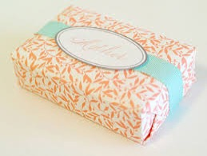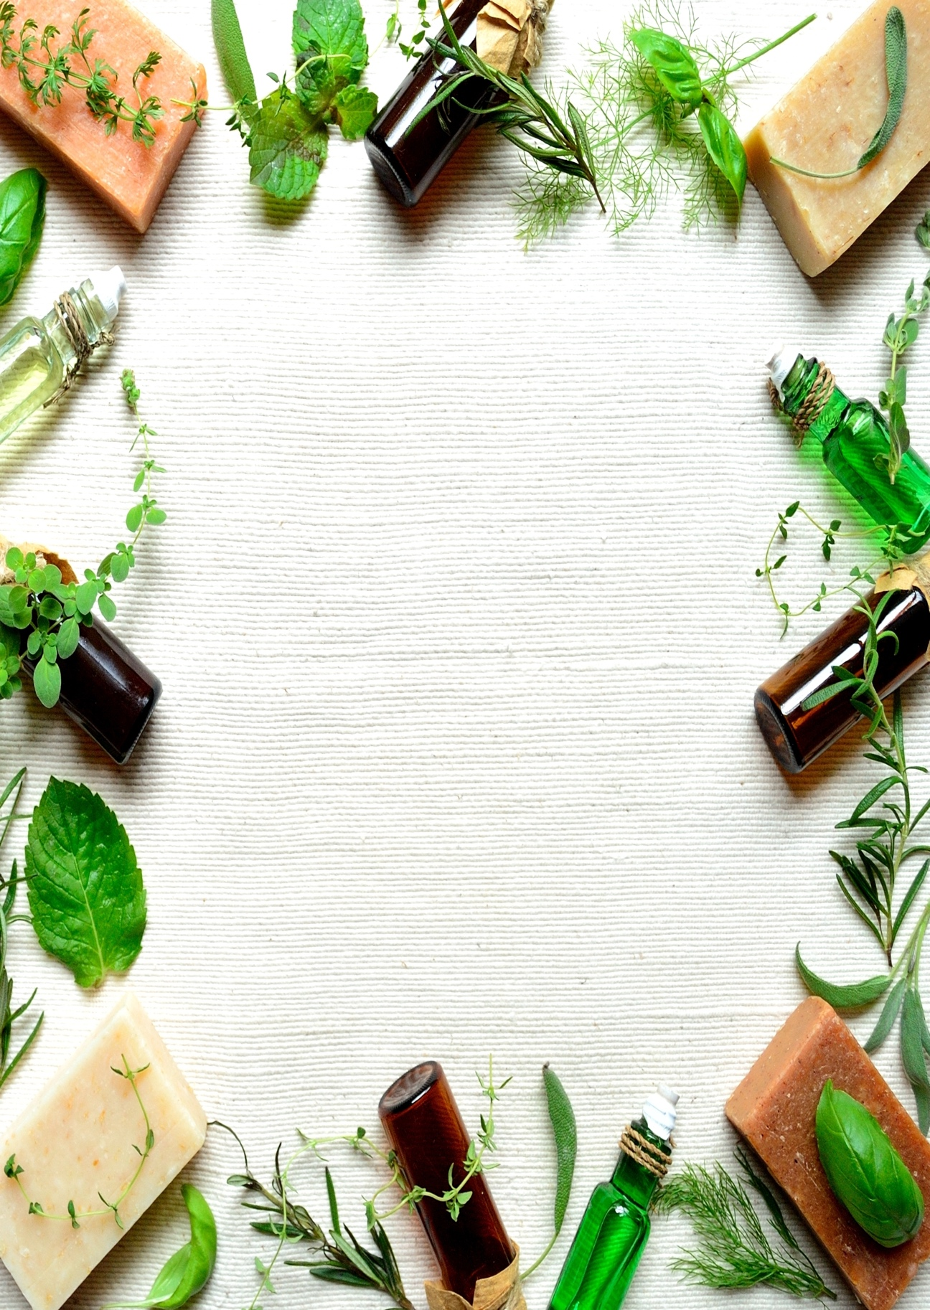

All our soaps are produced locally and sealed to keep it fresh. Fruit is one of the most healthy products to keep you sharp every day!

* 3 Fragrances
* Locally made
* Desinfectant

**YOUR NAME SOAP**

Locally made natural soap

Like us on

Sincor Road 24, PO Box 3902 phone: 077836722343

www.yournamejuice.com