APPLICATION FORM
Business-in-a-Box Programme 2017

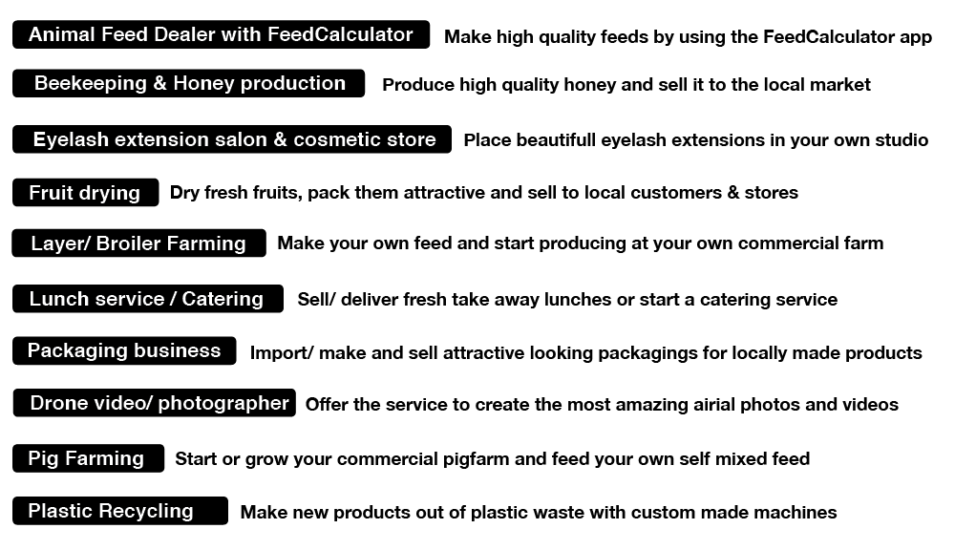
(See appendix for full business descriptions)

- Are you a female
- Do you see a big market potential for one of these businesses and always wanted to start it?
- Do you have your own similar business and you want to give it a boost to make it grow?
- Do you think you have the personality it takes to build a successful business, and grow it?
- With a push and some support you think you could make the business fly?

If you answered YES to most these questions – please read on.

BSC Monrovia, Spark and Single Spark are looking for female entrepreneurs like you for its new business-in-a-box program. We are looking for committed and creative entrepreneurs who can take the market gaps and innovations and turn them into successful businesses.

The Business in a Box has been designed to provide you with all necessary skills to succeed in the specific business. This includes production guidelines, marketing materials, financial management, golden tips and support to finance through loans to make the business a success.

Applicants should be able to contribute at least 10% of the seed money.

This is the moment to start your own business or to boost your current business!

Stages of the programme:

1) SELECTION ENTREPRENEURS
New and experienced entrepreneurs will apply to start 1 of the 10 businesses. The selection process will have two phases, the initial application phase and the interview phase. The best 30-40 high potential participants will be selected.

2) FEASIBILITY SCAN WORKSHOP
The workshop takes three days, thereafter a market research of one week will be conducted by the entrepreneurs. The entrepreneurs will present their results and the 20-25 best entrepreneurs will be selected to the next round.

3) BUSINESS PLAN WRITING
The selected entrepreneurs who believe in the business will be supported in writing a business plan.
A general business plan writing course will be given to the participants by the BSC Monrovia. Which makes it much easier to write the plan.

4) ACCESS TO FINANCE
To get the business operational, finance is needed. The participant of the program will present his or her business plan with the business-in-a-box to a preselected jury. The jury will decide whether the entrepreneur is ready for finance. Access to finance can be done through strategic start-up capital, equity financing, loans etc.

5) BUSINESS-IN-A-BOX
When the business plan is developed, the entrepreneur gets a on- and offline box, which guides him step-by-step how to start his business. The business-in-a-box encompass all the tools and information to ease the start up of that specific business. It contains tools like technical drawings, marketing materials and administration support, an overview of the production process and supporting financial tools. In short all practical guidelines and support to shorten the start-up period and the start-up cost.

6) SUPPORT
The entrepreneurs will get support during the first half year.

When selected you need to be available on the following dates
MONDAY 14th - THURSDAY 17th of August: Feasibility scan workshop and training (4 days)
WEDNESDAY 23th of August: Presentation of Feasibility Scan (selection moment)

Please complete the application form carefully if you are interested!

Deadline: 8th of August 2017 (before 23.59 hour)

APPLICATION FORM
Personal Background – applicant

1. Name:
2. Age:
4. Phone: Email:
5. Address:
6. Education (highest completed level or on going):
7. Briefly tell us about yourself? (e.g your working experience and what you are currently doing) (Maximum 50 words only)

Experience and interests
1. Which of the following business would you like to start/ grow?
(Must be a business proposed on page 1, or closely related to one of the businesses)

2. What is your experience in the business you have selected above?

3. Why do you think the business you have selected above has market potential?

4. What do you think the biggest challenge will be to start/ grow this businesses?

5. Why are you the right person to start or expand this business?

6. How much money do you estimate is needed to start/ grow the business?
a) Less than $5,000 b) $5,000 - $10,000 c) $10,000 or more

7. How much do you estimate you will be contributing yourself?
a) Less than $ 1,000 b) $1,000 - $5,000 c) $5,000 or more

Business experience
Fill in the next questions ONLY if you already have/had your own business

- What is the name of the business?

- Describe what your business does and who your customers are?

- How old is your business?

- What is the yearly revenue of your business? (approximately)

- Mention the biggest challenges you have in this business

Checklist
[ ] I am available on the dates of the programme (see page 2)
[ ] I am the entrepreneur that will start the business
[ ] I can speak/read the English language
[ ] I am able to make simple calculations
[ ] I am motivated and enthusiastic to make this business a success

Please submit your completed application form before 8th of August 2017, time: 23:59
on this email address: jeremytitoe@bscmonrovia.com
or at the following address:

BSC-Monrovia, University Campus, Capitol Hill, (behind basketball court)

For any problems call: BSC Monrovia tel: 088 081 7411
You can find this application form online at: www.singlespark.nl/liberia
We will contact you if you are selected for the next step before the 1st of July.

Thank you very much for your time!

