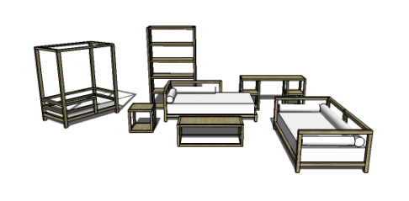

**YOUR NAME**

**CARPENTRY**

* Restaurant furniture
* Garden Furniture
* Educational toys

www.yournamecarpentry.com

Locally made!

Like us on

Sincor Road 24, PO Box 3902 phone: 077836722343