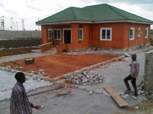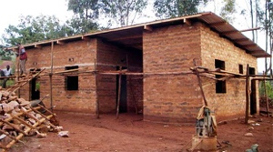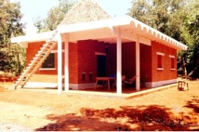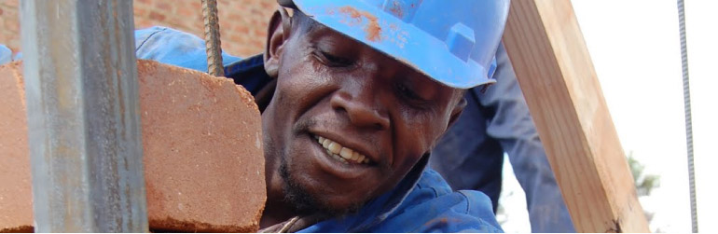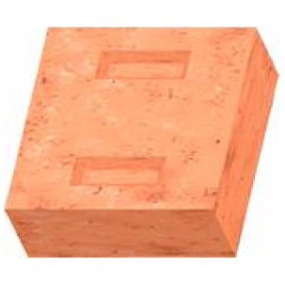****

Environmental

friendly

**Your Business Name**

**Your Business address**

**Your Telephone number  
Your e-mail/ website**

Your Business Name produces high quality CEB Blocks. CEB blocks our highly popular in our neighbouring countries and now also available here in Liberia. Our blocks are compressed by a machine. Due to the compression less cement is needed to give it the same strenght as cement blocks. This is not only good for the environment but also for your wallet. We make the blocks at your site or at our own production just to your satisfaction. Let's build Liberia together!

Your Name

**CEB-BLOCK**

Strong

Machine Made