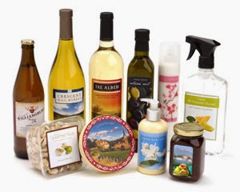****

We print professional labels in low and high quantities!

* Professional Labels
* High Quality adhesives
* Design studio

Like us on

Sincor Road 24, PO Box 3902 phone: 077836722343

All our fruits and juices are produced locally and sealed to keep it fresh. Fruit is one of the most healthy products to keep you sharp every day!

www.yournamelabels.com

**Your Name**

**LABEL PRINTING**