****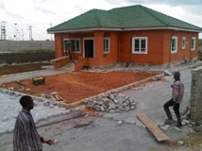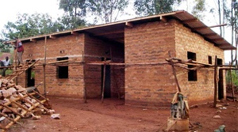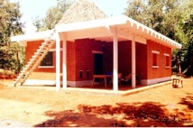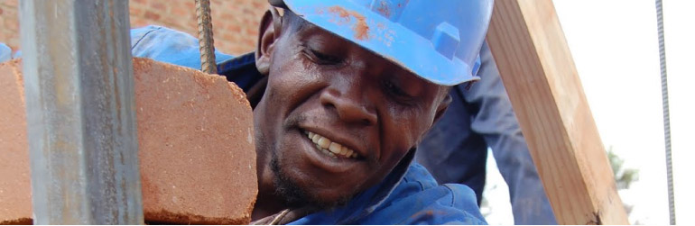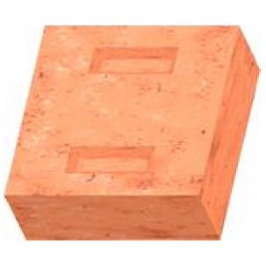

Your Name

**CEB-BLOCK**

Strong

Machine Made

Environmental

friendly

**Your Business Name**

**Your Business address**

**Your Telephone number  
Your e-mail/ website**